**Name (netid):** Your Name (Your Netid)

**CS 445 - Project 2: Image Quilting**

Complete the claimed points and sections below.

**Total Points Claimed [ ] / 175**

**Core**

1. Randomly Sampled Texture [ ] / 10
2. Overlapping Patches [ ] / 20
3. Seam Finding [ ] / 20
4. Additional Quilting Results [ ] / 10
5. Texture Transfer [ ] / 30
6. Quality of results / report [ ] / 10

**B&W**

1. Iterative Texture Transfer [ ] / 15
2. Face-in-Toast Image [ ] / 20
3. Hole filling w/ priority function [ ] / 40

**1. Randomly Sampled Texture**

Include

* Sample and output images
* Parameters: patch size, output size

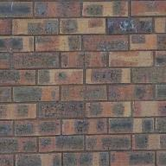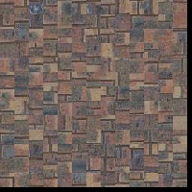

out_size = 200

patch_size = 15

**2. Overlapping Patches**

Include

* Output image for same sample as part 1
* Parameters: patch size, overlap size, tolerance

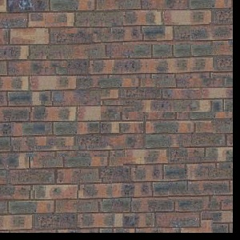

out_size = 300

patch_size = 25

overlap = 11

tol = 3

**3. Seam Finding**

Include

* Output image for same sample as part 1
* Illustration: for a selected patch, display (a) the two overlapping portions; (b) pixelwise SSD cost; (c) horizontal mask; (d) vertical mask; (e) combination mask. The mask is binary and tells which pixels come from which patch.
  + Note: we’ll accept anything that looks like a genuine attempt to meet illustration instructions. (a) was intended to mean the two RGB patches (template and selected) that are being cut; (b) can be the SSD values of all the overlapping pixels (i.e. per-pixel SSD masked by template mask), or either one of the SSDs that you feed into cut.

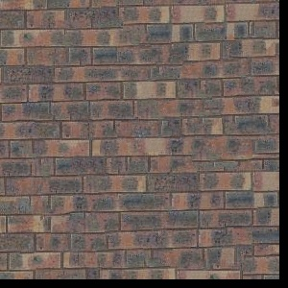

out_size = 300 # change these parameters as needed

patch_size = 25

overlap = 11

tol = 5

a)

overlap old:

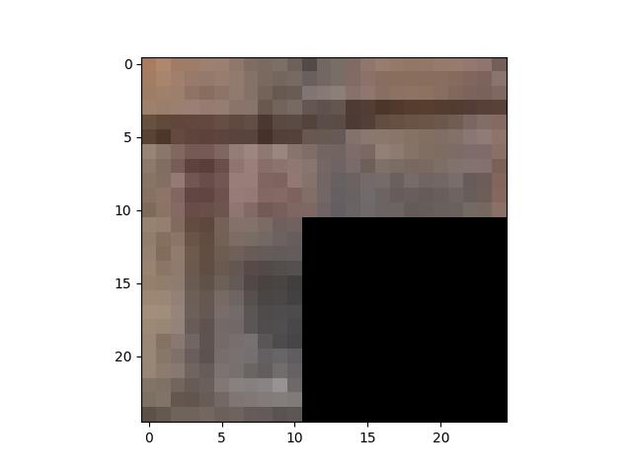

overlap new: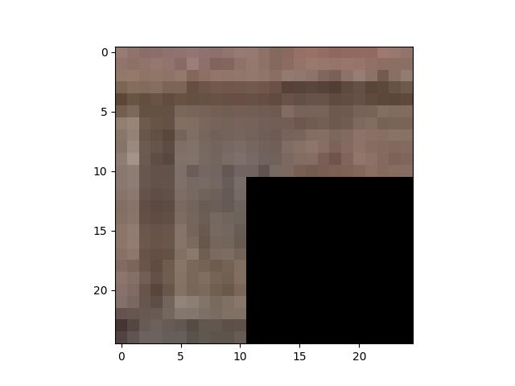

b)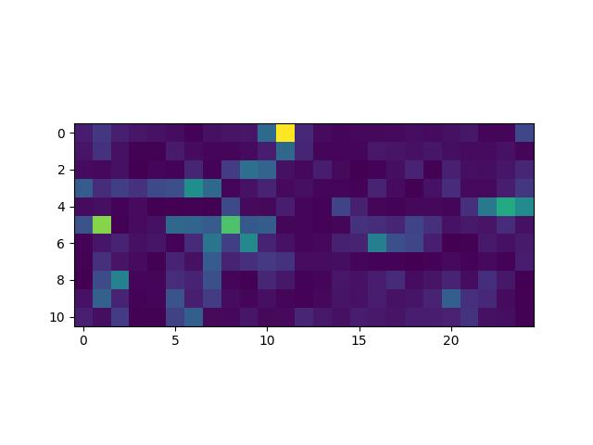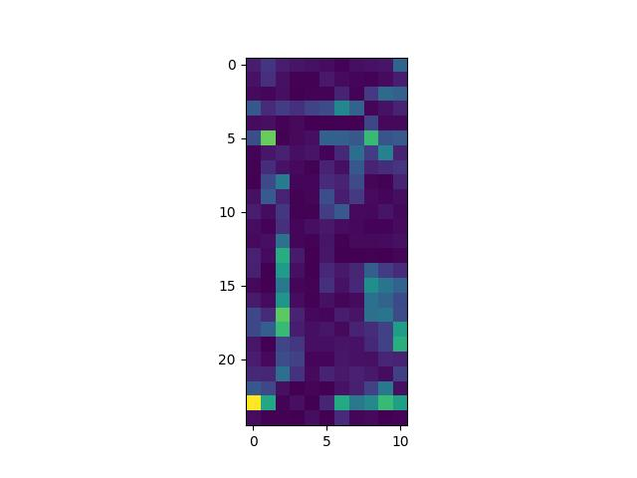

c)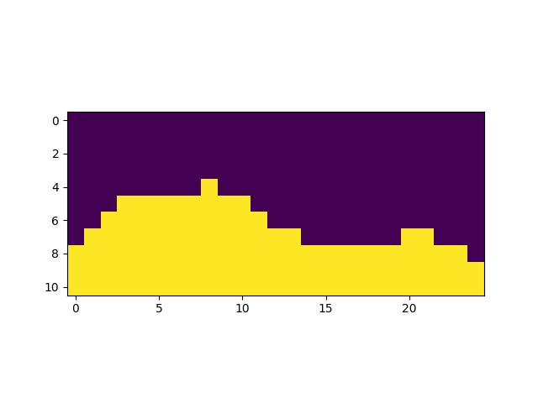

d)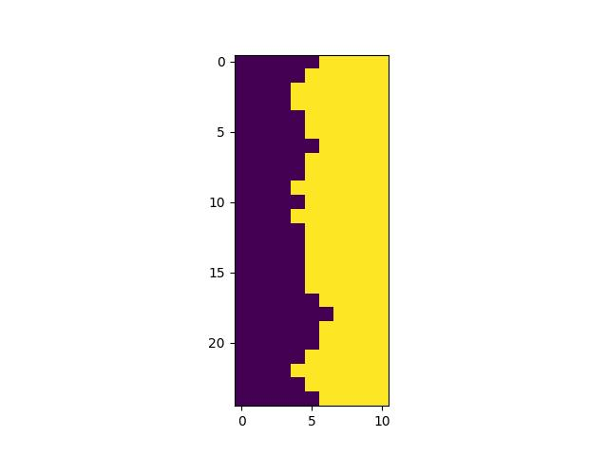

e)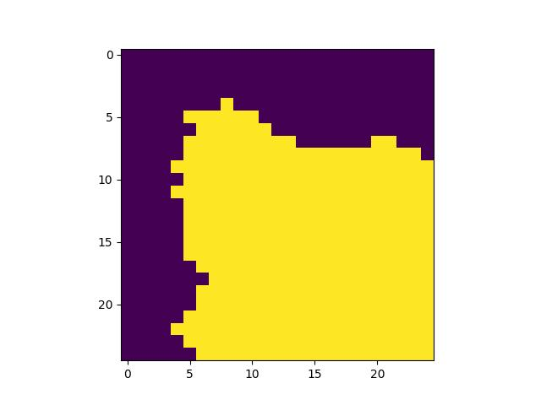

**4. Additional Quilting Results**

Include

* At least two quilting results on your own images (excluding provided samples). Each result should show input texture image and output, and output should be more pixels than input.

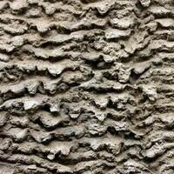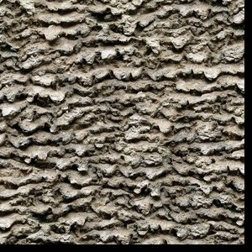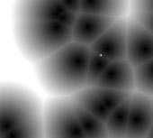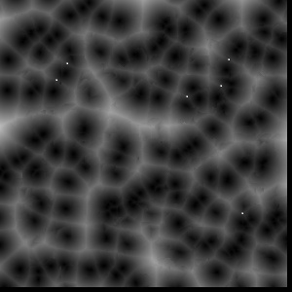

**5. Texture Transfer**

Include

* Brief description of texture transfer method and parameters
* At least two texture transfer results (one result can use provided samples). Include the input texture and target images and the output (output should be same size as target image)

The texture transfer method is largely the same as the quilting technique, but with an additional constraint to the error. When finding a new appropriate patch in the sample texture, besides comparing the overlap region, it also compares the luminance of the current position of the target image with the texture. The additional parameter “alpha” controls the weight of the two components. A large alpha means caring more about the continuity of the texture rather than the original shape of the target image.

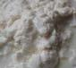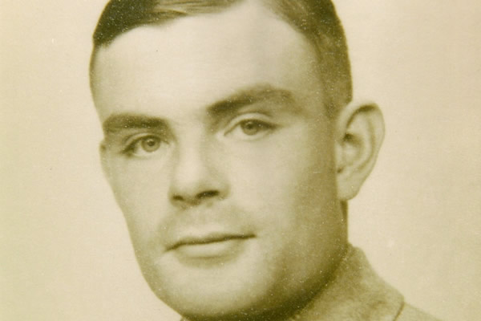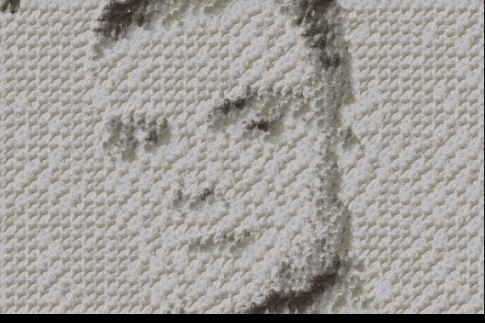a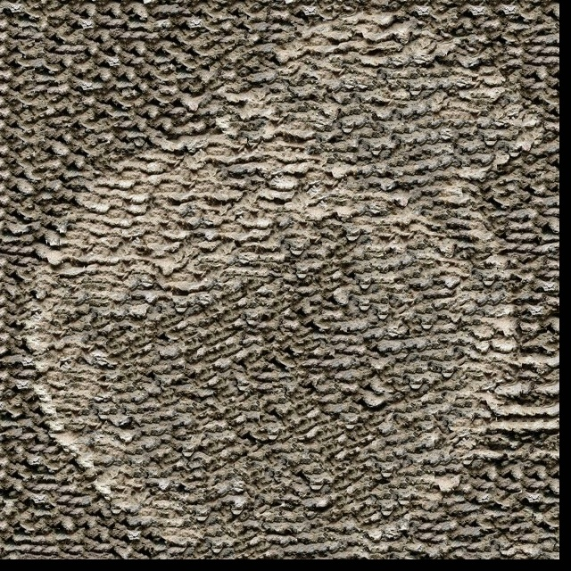

**6. Quality of results / report**

Nothing extra to include (scoring: 0=poor 5=average 10=great).

**7. Iterative Texture Transfer (B&W)**

Include

* Describe method
* Results on same images as shown for texture transfer.

**8. Face-in-Toast Image (B&W)**

Include

* Describe method
* Show input face image, toast image, and final result

**9. Hole filling w/ priority function (B&W)**

Include

* Describe method
* Show result on at least two images (show input with hole and output)

**Acknowledgments / Attribution**

List any sources for code or images from outside sources

apple: <https://depositphotos.com/cn/photo/red-apple-with-leaf-18689193.html>

rock: <https://www.nyfa.edu/student-resources/using-texture-subject/>

cell: <https://www.gamedev.net/tutorials/programming/graphics/cellular-textures-the-light-speed-approach-r2668/>

Alan Turing: https://www.losangelesblade.com/2019/07/16/alan-turing-will-be-face-of-britains-new-50-note/